Updraft

The Programmers Documentation

Team Leader :

Tomáš Zámečník

Team Members :

Čestmír Houška

Jakub Marek

Bohdan Maslowski

Mária Vámošová

Aleš Zita

Project Supervisor :

Alexander Wilkie

Faculty of Mathematics and Physics,

Charles University,

Prague,

Czech Republic

07-May-12

# Table of content

Table of content 1

1 Introduction 3

2 The Updraft project 4

2.1 The Team 4

2.2 Technical details of development 5

2.3 Repository structure 5

2.4 Project specification 6

2.4.1 Environment 6

2.4.2 Supported languages 6

2.4.3 Negative specification 6

2.4.4 List of features 6

2.4.5 GUI principles 7

3 Third Party Software 8

3.1 Nokia Qt 8

3.2 OSG 8

3.3 OSG Earth 8

3.4 GeographicLib 9

4 The third party data 10

4.1 introduction 10

4.2 Map imagery sources 10

4.3 Elevation data source 11

5 Program Architecture 12

6 The Core 13

6.1 Overview 13

6.2 Top Level Structure 13

6.3 Plug-in Base Class 14

6.4 Core Interface 15

6.5 PluginManager 15

6.6 Translations 15

6.6.1 Translation Files 15

6.6.2 Loading of Translations 15

6.6.3 Available Languages 16

6.6.4 Runtime Translations 16

6.7 Map Downloader 16

7 The Plugins 17

7.1 Introduction 17

7.1.1 Plug-in creation 17

7.1.2 Minimal Plug-in Example 17

7.2 Airspaces 19

7.2.1 Introduction 19

7.2.2 Overview 20

7.2.3 Design 20

7.2.4 OpenAir(tm) parser 21

7.2.5 OpenAir(tm) drawing engine 23

7.2.6 3rd party software used 25

7.2.7 The Airspaces plug-in diagram 26

7.3 TurnPoints 27

7.3.1 Introduction 27

7.3.2 Overview 27

7.3.3 Design 28

7.3.4 TPLayer Class 28

7.3.5 TPFileCupAdapter Class 28

7.3.6 Cup File Parser 28

7.3.7 Turnponts Plug-in Diagram 28

7.4 Task Declaration 30

7.5 IGC Visualisation 31

7.5.1 Introduction 31

7.5.2 Model 31

7.5.3 Igc Parser 32

7.5.4 IGC Viewer plug-in 32

7.5.5 Plug-in Design Scheme 37

8 Program installation 39

8.1 Windows 39

8.2 Linux 39

8.3 Mac 39

9 Conclusion 40

10 Future work 40

11 References 41

12 Tables 43

13 Figures 44

14 Appendix A – People 45

15 Appendix B – OpenAir(tm) airspace format definition 46

16 Appendix C – Cup File Format Description 48

17 Appendix D – Elevation dataset usage confirmation 50

18 Appendix E – DVD content 52

# Introduction

There is more to gliding then just jump into the airplane and fly. The ground preparation is nearly as important as the flying itself. And this fact holds not only for commercial or military pilot, but for sport glider pilot too. For instance every competition flight needs to be planned in advance as well as analysed after the flight is done.

The post-flight analysis or so-called debriefing is the process during which the pilot takes the stored flight path recordings and scrutinises the data or re-plays the flight to further analyse the flight or learn from it. As for planning of the competition flight there are sets of pre-defined *turn-points* from which usually the three turn-points are chosen to form a competition triangle. Every turn-point is defined by its world coordinates. During the competition flight, the pilot needs to navigate his/hers airplane through these waypoints in pre-defined order for his flight to be valid. Although this planning can be done by hand, the use of computer program is very convenient. Therefore a need of software that can be used for these tasks has arisen. To our knowledge there are few free and commercial solutions on the market. However the free software doesn’t match the quality of the commercial applications and the commercial applications are expensive. One of the widely spread commercial software for this purposes at the present time is a application called *SeeYou* [1] created by the *Naviter* company, which we use as an inspiration.

Our aim is to create similar (in functionality) open-source product under the GNU license and therefore made this product available to wider glider pilot communities. We try to improve on some of the SeeYou features, which we believe can be done in more user friendly manner. We would not like our product to be compared to SeeYou, but rather taken as a free-of-charge alternative. To achieve this uneasy task we have setup the group of skilled programmers and flight enthusiasts, who has spent many a night and day to realize such a project. We call our project **The Updraft[1]**.

# The Updraft project

## The Team

This subject was originally proposed by our Project Leader *Tomáš Zámečník*. He, as an enthusiastic glider pilot, has pointed out the lack of high-quality non-commercial glider path planning and visualisation software. Team of people fond of flying was established with *Tomáš Zámečník* as a project leader. Finally, the team consists of 6 people.

**Team members:**

* **Tomáš Zámečník**
* **Čestmír Houška**
* **Jakub Marek**
* **Bohdan Maslowski**
* **Mária Vámošová**
* **Aleš Zita**

See the “*Appendix A – People*” for further details.

Programming of the Updraft project was divided into several partially separable parts with each of the part dedicated to one team member. Obviously it was impossible to split the workload evenly, so most of the people ended up working on parts of the project in groups and tight cooperation between team members proved crucial. However there always was a tendency for having one responsible person for each of the project component. The Table 1 shows every member main responsibilities. The work was well coordinated and project meetings were held on weekly basis. On several occasions the team brain-storming was organised, resulting in marginal work progress or brilliant issue solutions. For e-mail communication we used services of *freelists.org* for its accessibility and transparency. The established group e-mail address is [glideplan_swproj@freelists.org](mailto:glideplan_swproj@freelists.org).

|  |  |  |
| --- | --- | --- |
| **Developer** | **Updraft component** | **Main responsibilities** |
| Tomáš Zámečník | Turnpoints plug-in, TaskDecl plugin | Leadership and management, Turnpoints plug-in, User documentation, TaskDecl plug-in,  Importing files |
| Čestmír Houška | Core, GUI | Updraft core, Settings, TaskDecl. GUI, Mouse picking |
| Jakub Marek | IGC plug-in, Core | Core, IGC visualisation, IGC parsing, Translations, Bottom panel interface, OpenFile dialog |
| Bohdan Maslowski | GUI, installation | Mac Updraft version, Installation packages for all platforms, 2D Map mode |
| Mária Vámošová | IGC plug-in, GUI | OSG Earth implementation, Map layers visualisation, IGC graph drawing, IGC statistics, Camera manipulation, Map Layer groups + left pane interface, Scene manager |
| Aleš Zita | Airspaces plug-in, documentation | Airspace plug-in, documentation, turnpoint labels, airfields visualisation |

Table 1 : Team members main responsibilities.

## Technical details of development

The programming language we choose for the Updraft implementation was C++ for both the object oriented characteristic of the language and overall advancement of this language’s features and possibilities. To keep the complexity of the language on a manageable level, we decided to use a Google C++ style guide [3]. Google C++ style guide is one of the widely used open-source set of suggestions and recommendation on how to maintain the readability of the code. The style checker was incorporated to the build of the project to ensure the rules would be followed.

On top of the main programming language we decided to use Nokia Qt framework [4] for its multiplatform user interface capabilities. Nokia Qt is a development framework used for creation of applications for many platforms including Windows, Linux, Mac OS, Symbian and many others. One of the goals we set was to have Updraft usable under not only Windows, but under Mac OS and Linux operating systems as well, because these are 3 most common operating systems nowadays.

The program was developed on Windows and Linux platforms and tested on Mac. As a development environment we used the Microsoft Visual Studio 2008 [5] under student license on Windows and vim-editor on Linux.

*CMake* [6] was used as a cross-platform project build system.

## Repository structure

We used the *Git* version control software and hosted the source code on the *GitHub* web hosting service. We have chosen the GitHub, because it offers free accounts and storing space for open-source project, such as ours, and for very convenient possibility of creating our product’s web page. The web-page address of our product can be found on <http://updraft.github.com>. The project repository is accessible via Internet on <https://github.com/updraft>. The repository structure of our project is as follows:

* updraft.github.com - Project web page files.
* Updraft - Project main repository folder.
  + Docs - Documentation related files
  + Experiments - Project experiments with 3rd part SW installation.
  + SourcesInstallation - Test files for source code installation.
  + Updraft - Source code repository.

## Project specification

### Environment

The goal of this endeavour is to create multiplatform desktop application capable of serving as a glider pilot tool for flight planning and post-flight visualisation. The target platforms are Linux, Microsoft Windows or Mac OS. Connection to the internet is not required, but enables some of the functionality.

### Supported languages

Application is distributed in Czech and English localisations.

### Negative specification

The software is not intended to be used by competition directors or referees or for judging the achievements of any official goals. Application will not be focused on detailed flight planning like calculating optimal speed, water ballast, final glide etc. The application will not run on mobile devices and will not serve as an on‑board computer.

### List of features

The features include the visualisation of 3D maps including the terrain height, visualisation of flight relevant data, such as airspace divisions, turn-points, airfields, etc., next to the flight planning and visualisations of recorded IGC files.

The tools we contained within the final product are:

* flight planning (called task declaration)
* airspace visualisation
* turnpoints and airfields visualisation
* flight path visualisation with colour-coded information about
  + speed
  + vertical speed
  + altitude
  + airspeed

### GUI principles

Most of the action is done by mouse.

# Third Party Software

As this is an uneasy task, we made our work a little bit easier by utilizing several 3rd party frameworks, which help us to create the application. These are :

1. *Nokia Qt* [4] – the multiplatform User Interface
2. *OSG* [9](the open scene graph) – as a OpenGL interface for 3D geometry visualization
3. *OSG Earth* [10] – as a tool for the world map visualization
4. *GeographicLib* [11] – for exact ellipsoid distance calculation

## Nokia Qt

*Nokia Qt* [4] is a cross-platform development framework used for creation of applications with graphical user interface (GUI) for many of the operating systems including Windows, Linux, Mac OS, Symbian and others. Nokia Qt is a free and open source software distributed under the terms of the GNU Lesser General Public License. As it has been always our goal for Updraft to be multi platform application, we decided to use the Nokia Qt framework because it is ideal for this task. Moreover, the Nokia Qt is known to be able to incorporate the OSG efficiently. Nokia Qt uses standard C++ but makes extensive use of special code generator called the *Meta Object Compiler*, or *moc* together with several macros to enrich the language.

## OSG

The *OpenSceneGraph* is an open source cross-platform 3D graphics application programming interface used in fields such as visual simulation, games, virtual reality, scientific visualisations and modeling. The OSG is distributed under OpenSceneGraph Public License based on LGPL licence. It uses the *OpenGL* for 3D graphics acceleration interface. We use the OSG as a base for the OSGEarth framework, which we decided to use for the worldwide map visualisation.

## OSG Earth

The *OSGEarth* [10] is a terrain rendering toolkit written in C++ and distributed under LGPL license. It is developed by Jason Beverage and Glenn Waldron as a visualisation toolkit for the map, elevation and vector data. OSGEarth utilises the OSG framework as the 3D graphics interface.

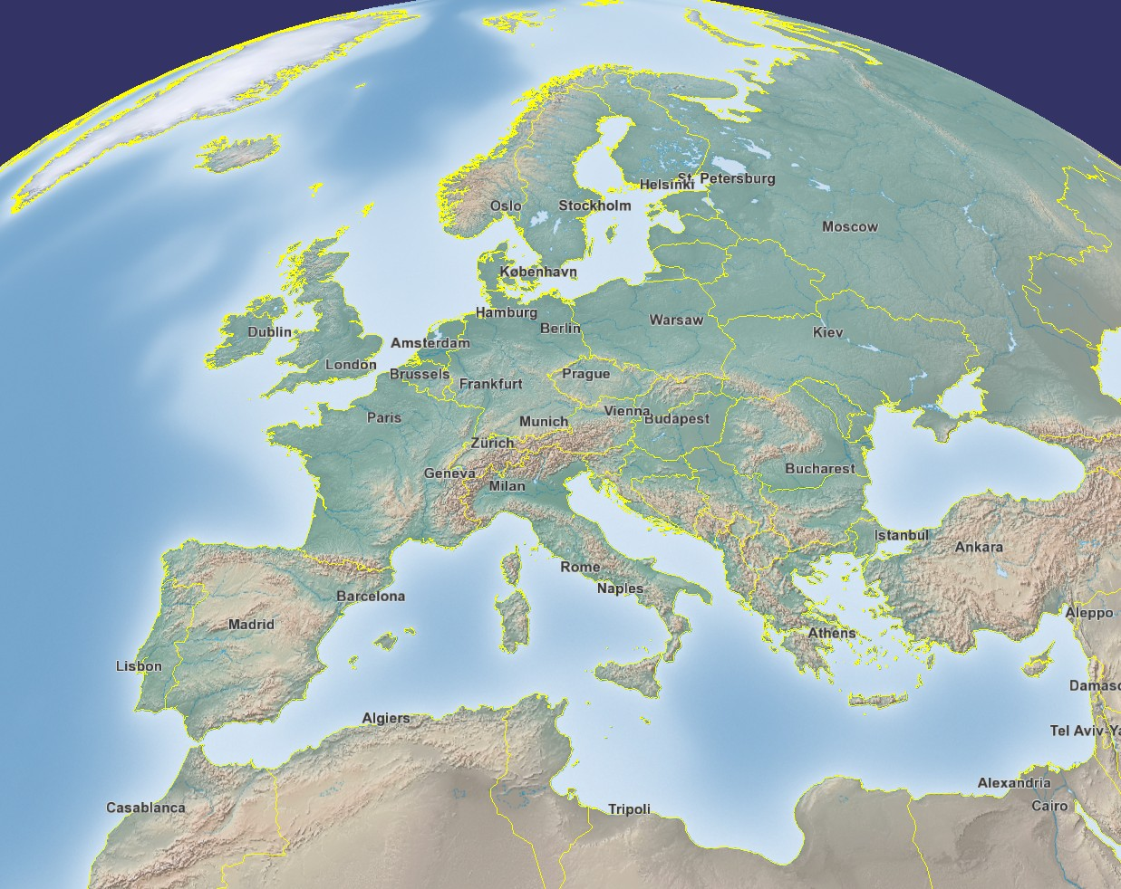

Figure 1. The OSGEarth framework example.

## GeographicLib

The GeographicLib is a small C++ project for solving geodesic problems. The library is licensed under the [MIT/X11 License](http://www.opensource.org/licenses/MIT). In our project we use a small part of the code for very exact computation of distance on the geode surface.

# The third party data

## introduction

So far we described the environment we chose for our project development. OSGEarth is a superb framework for visualising the map imagery and elevation data of various sorts. For map data processing we decided to use the online/caching strategy. As a source we use the data sets which are available online because of minimal necessary installation packaging. We cache the data once downloaded from the internet to limit the bandwidth requirements to minimum level and boost up the speed of the map drawing. In this way the application is capable of displaying the map data from all over the globe without the necessity of all the data being stored locally. This solution also prevents the distribution package to be oversized. Note that these data packages are enormous in size for obvious reasons. Therefore the internet connection during the application run is highly advisable but not essential once the map data are cached. We distribute the application with a basic set of cached map data in reasonable size to resolution ratio for users without internet connection to be able to use the application. Additionally the application allows user to pre-cache map data with the map caching tool for later off-line application usage.

Two types of data sources are necessary for visually pleasing display of the world, the map imagery data and the elevation data. There are several free data sources available online for the map imagery, but not so much for the elevation data.

## Map imagery sources

In order to display the world map we need to use a free database of map imagery data. This data set needs to be in one of the format supported by the OSGEarth framework. The complete list of the OSGEarth drivers capable of process particular data sources are listed on the OSGEarth web page[2]. The configurations of the particular data sources are written in the ‘*.earth’ file stored in /bin/data directory.

In our case we wanted to have at least two basic views of the virtual world. We pick the sources in following manner: one to be very simple for the sake of the visualisation clarity and the other to be the “realistic” view, i.e. the photomaps with the elevation displayed as a terrain displacement.

Map imagery data sources used:

* OpenStreet map - free worldwide map tiles database hosted on under open licence
* ArcGIS online map service- free[3] worldwide satellite tiles imagery database
* ArgGIS online map service – free[4] worldwide topographic map tiles database

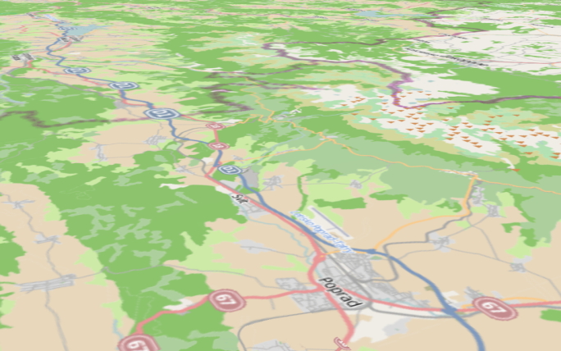

Figure 2. OpenStreetMap source.

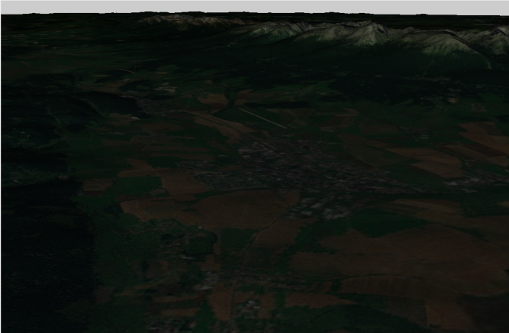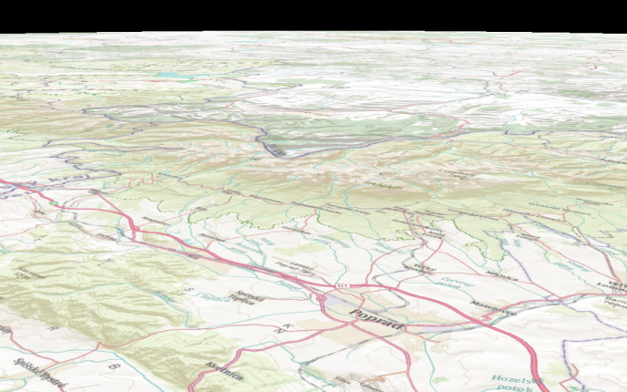

Figure 3. ArcGIS online map service.

## Elevation data source

As for the elevation (so-called heightfield) data source we use the Ready Map elevation data source. Beacuse this data source is designated for development purposes only, we asked the author for permission to use this data set for our project. The permission was granted and the corresponding e-mail is attached to this document. See Appendix C – Elevation dataset usage confirmation.

# Program Architecture

The application is designed as a core/plug-ins architecture with the core being responsible for user interface, map visualization, settings, file importing and plug-in handling. The plug-ins are linked as a dynamic libraries to the main project and represent the main features functionalities. Plug-ins use the core functions and methods for drawing to the map layer, creating plug-in related menus, mouse click actions, file handling, settings, etc. The core/plug-in communication is represented by a system of Qt signals and back calls between both components. Example scenario is that plug-in needs to react to a user action captured by the user interface (core) such as mouse click on map or the plug-in map item visibility change.

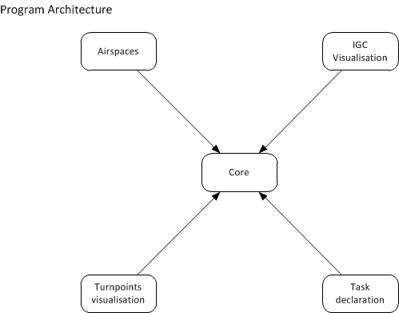

Figure 4. Application architecture diagram.

# The Core

## Overview

The core provides the basic functionality of Updraft - maps, settings, menus, GUI, mouse actions handling, etc., whereas the plug-ins handle everything else. Therefore, the core has to provide everything that the plug-ins could possibly need. This includes map mouse picking, handling the GUI and menus, saving and loading the plug-in's settings, loading the application data from the correct directory and registering a known file type. All of this functionality can be accessed via core interface. Each plug-in has access to this core interface and can thus use its functions. For loading the plug-ins dynamically at runtime, Updraft uses the Qt's Plug-in system.

## Top Level Structure

Top level object of the application is class `Updraft` defined in Updraft/src/core/updraft.h and Updraft/src/core/updraft.cpp. This class inherits from *QApplication* and is available for the whole core as *updraft* macro. It is responsible for creation of the main application structure.

Below the *Updraft* object there are five managers that handle separate aspects of the application functionality and the main GUI window.

Managers have dependencies between themselves, that force the order in which they are

created. Additionally some of the dependencies are circular (see Figure 5) and need to be broken by dividing the initialization of these objects into smaller parts.

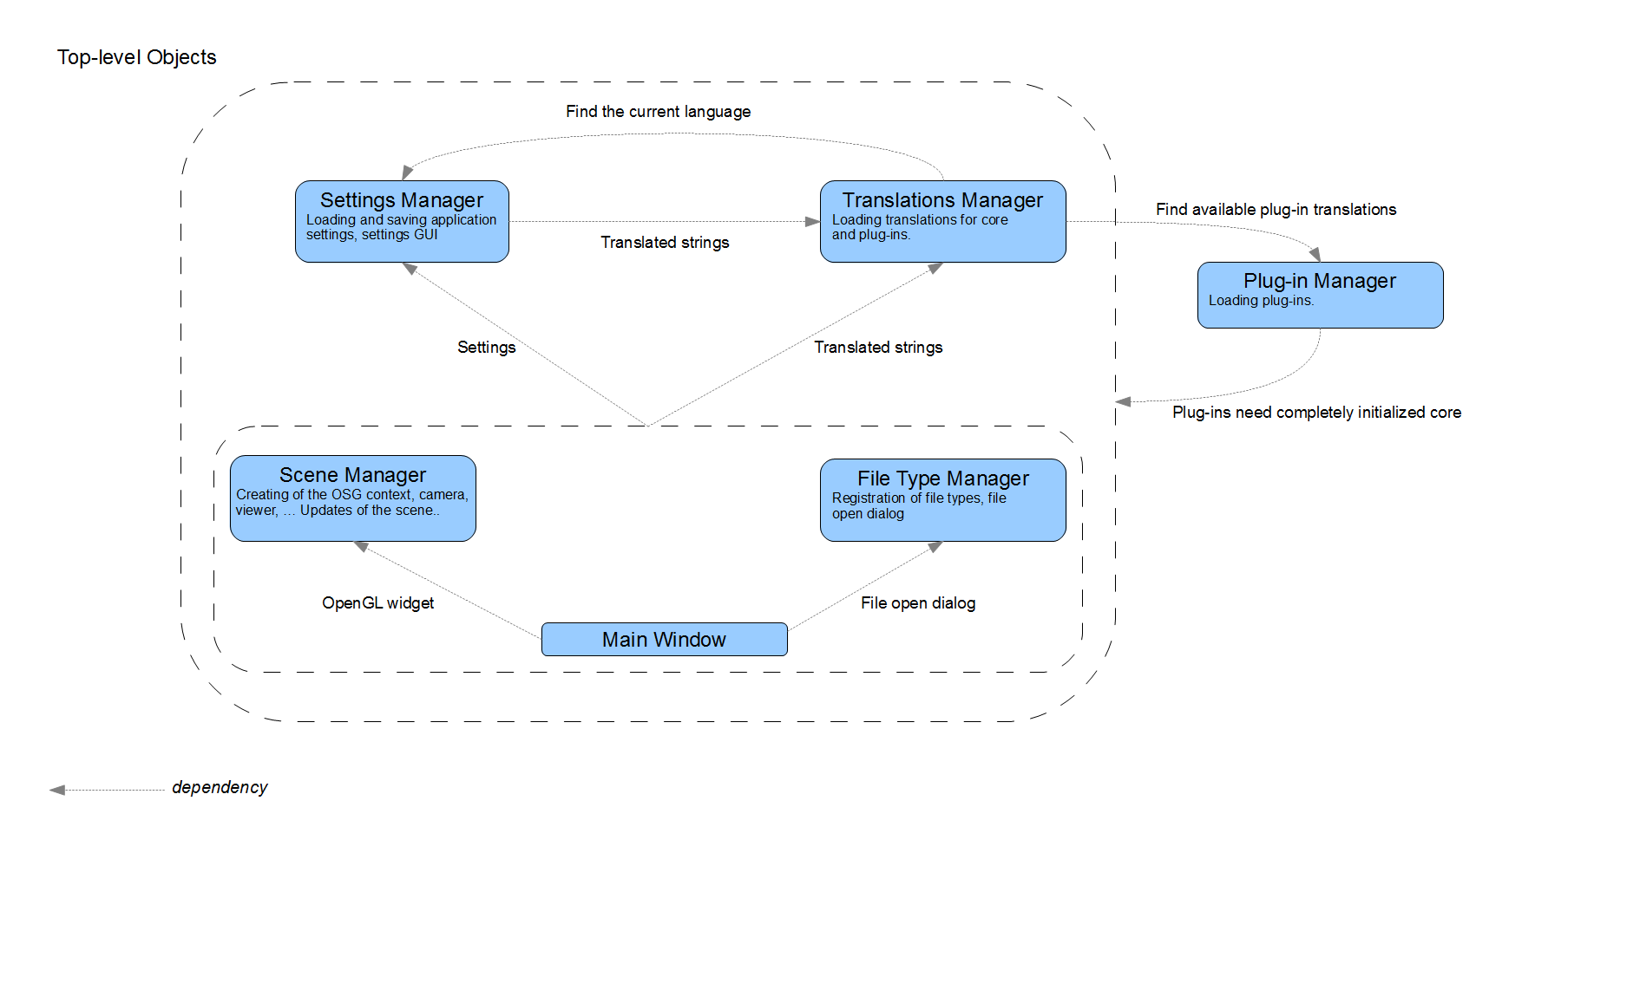

Figure 5. Top level structure diagram.

The order of initialization is following:

* *Settings Manager* needs to be initialized first, because it contains paths to data files and selected language. However it cannot be completely initialized until the Translation Manager is ready to translate settings dialog and until the main window is ready to add the main menu items.
* Next the *Plug-in Manager* is created. It finds and loads all available plug-ins, but because plug-ins need a core interface to work, plug-in manager has to wait with calling their *initialize()* method until all other managers are completely initialized.
* Third in the order of creation is the *Translation* *Manager*. It only depends on Settings for the current language setting and on Plug-in Manager for a list of loaded plug-ins (to find their available translations).
* After these are created other application global objects are prepared and then the start up continues with creation of the *Main* *Window*, *File* *Type* *Manager* and *Scene* *Manager*.
* Finally the *OpenGL* *display* *widget* is added to main window and initialization of both the Settings Manager and the Plug-in Manager is finished.

Apart from initializing the managers, class *Updraft* also provides some application wide values, like path to current data directory and selectable ellipsoid models for distance calculations.

## Plug-in Base Class

Every plug-in in Updraft has to be derived from the *PluginBase* class. This class provides several handler methods that can be overridden by each plug-in to provide the desired behaviour. These methods allow the plug-in to initialize data upon load, de-initialize data when the plug-in is unloaded, and add context-menu items into *MapObject*-related context menus (more information about map objects in section Map Objects), react on left mouse clicks on map objects and also process a file that is being opened by the core. Each plug-in should also provide its name by overriding the method *getName()*.

The *PluginBase* class as a Qt plug-in interface is using Q_DECLARE_INTERFACE.

## Core Interface

Interface *CoreInterface* enables the plug-ins to communicate with Core. It is passed to the plug-in during its initialisation phase (every plug-in gets its own instance) and it contains pointer to the plug-in. This makes it possible to attribute all calls to the source plug-in (although this option is currently not used). *CoreInterface* is implemented by a core class *CoreImplementation*, however this class contains only thin wrappers around various parts of the high level managers.

## PluginManager

On the side of Updraft Core, the class *PluginManager* takes care of loading plug-ins. The public interface of plug-in manager is fairly limited, only listing all loaded plug-ins and retrieving plug-in instance or plug-in directory by name.

## Translations

Updraft uses *Qt Linguist* for translations. The source strings in the application are written in English, and every other language gets its own translation file.

### Translation Files

Using the *lupdate* tool, Linguist keeps ‘*.ts’ files generated from the source code of the application. These files can be edited using the translation tool and during build they are converted to binary ‘*.qm’.

In our application both the updates of ‘*.ts’ files and the generation of `*.qm` files is controlled by CMake scripts.

### Loading of Translations

There is a specialized *QTranslator* instance for every plug-in and for core. During application start-up the translation manager reads the setting that selects the current language and attempts to load the corresponding `*.qm` files. There is a slight difficulty when registering the language setting, because registration needs a description for the setting and there is no way to translate it at that stage. This problem is avoided by first creating the setting with empty description and setting the translated description after the language is loaded.

### Available Languages

When the translation manager lists available languages it lists all `*.qm` files in a directory of each plug-in and in the directory of the main updraft executable. Base names of these files and "e*nglish*" are used as names of languages.

### Runtime Translations

Linguist supports changing translations during runtime using the *languageChange* Qt event. However every string has to be translated as a reaction to this event which is problematic especially for *QAction*`s and for strings generated during initialization of plug-ins. For these reasons Updraft only loads translations on start-up.

## Map Downloader

Map downloader is an utility for downloading maps for a user defined area. In fact, it pre-seeds the map-cache used by the program. It is a simple class that provides user interface for defining the area and the level of detail, with an option to fill the values to current view. Current view is get by the intersector.

Cache seeding is implemented by calling *osgEarth::CacheSeed* class.

# The Plugins

## Introduction

### Plug-in creation

A new plug-in must contain the main class inheriting from *PluginBase* and *QObject.* Additionally, the class must be marked as *Q_DECL_EXPORT* and *Q_INTERFACES* (*Updraft::PluginBase*), and it's implementation must contain *Q_EXPORT_PLUGIN2* (*pluginName, PluginClass*) outside all functions.

As a convention, we manually add a global variable *g_core* to all plug-ins to simplify access to the core interface in other classes of the plug-in.

### Minimal Plug-in Example

This example shows the mandatory steps to be taken for succesfull plug-in creation.

In file /Updraft/src/plugins/foo/fooplugin.h

#include "../../pluginbase.h"

class Q_DECL_EXPORT FooPlugin

: public Updraft::PluginBase, public QObject {

Q_OBJECT

Q_INTERFACES(Updraft::PluginBase)

public:

QString getName();

void initialize(Updraft::CoreInterface *coreInterface);

void deinitialize();

};

In file /Updraft/src/plugins/foo/fooplugin.cpp

#include "fooplugin.h"

Updraft::CoreInterface *g_core = NULL;

QString FooPlugin::getName() {

return "foo";

}

QString FooPlugin::initialize(Updraft::CoreInterface *coreInterface) {

g_core = coreInterface;

}

QString FooPlugin::deinitialize() {}

Q_EXPORT_PLUGIN2(foo, FooPlugin)

In file /Updraft/src/plugins/foo/CMakeLists.txt

cmake_minimum_required(VERSION 2.8)

PLUGIN_BUILD(foo)

## Airspaces

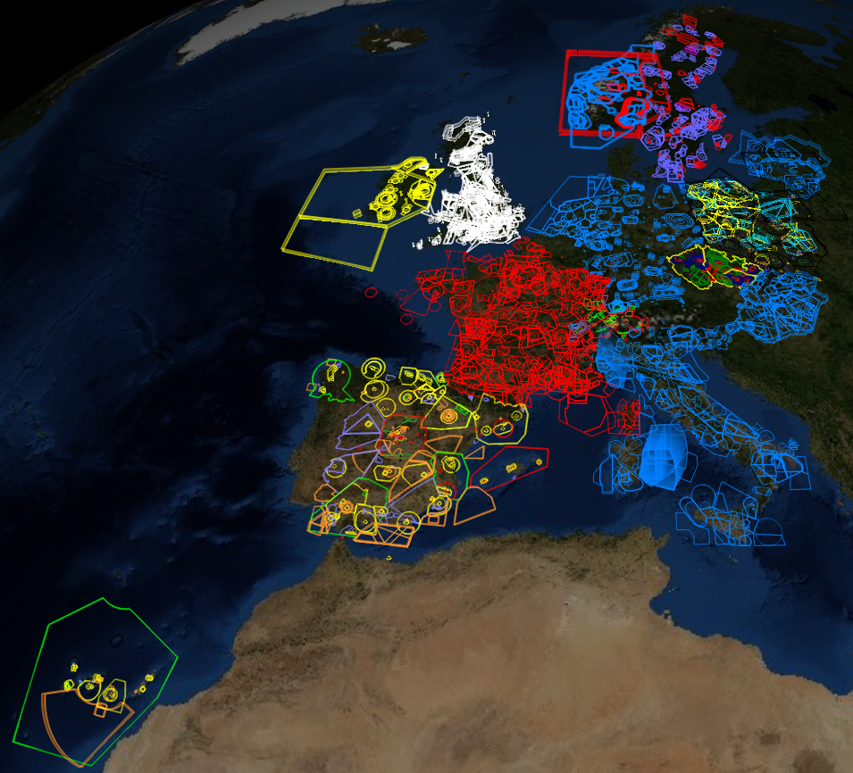

Figure . Western European Airspaces.

### Introduction

One the most important information for a pilot planning his flight is to know where he is actually allowed to fly. The air space is divided into several sectors defined by its shape and a top and bottom altitudes. Each such a defined part of the air space belongs to a particular class, which will tell the pilot more about its availability. There are for example military airspaces, no fly zones or restricted areas, the pilot must be aware of, otherwise risking high fine or even worse kind of countermeasures. This type of awareness is vital for every pilot flying. As these information are so crucial, the pilot usually uses the approved maps, which are costly, and cannot rely on open-source data. On the other hand, if the pilot wishes to use the visualisation tool to check the proximity of any airspace to his flight path after the flight is done, the open-source data are usually sufficient approximation of the reality. These may not replace the approved maps but can rather serve as an eye-candy in post flight visualisation. The files containing such a data are commonly accessible via the Internet. Therefore we like to provide the user with a tool for visualisation of these data. As the most common format used in Europe is the OpenAir(tm)[5] text format, we decided to incorporate the OpenAir(tm) airspace definition format parser into the application as well as the visualisation algorithm to draw these information on the map surface. For more detail please see the Appendix B – OpenAir(tm) airspace format definition.

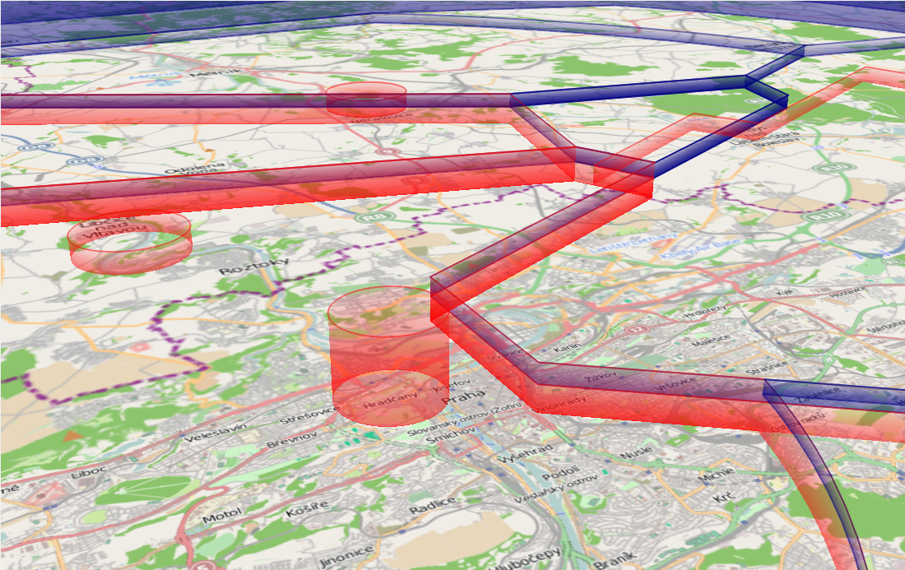

Figure 7. Example of airspace divisions visualisation.

### Overview

The main role of this plug-in is to parse an airspace definition data from the provided file and visualize them.

The basic and at the time of the first program release the only format is the OpenAir(tm) format (see Appendix B – OpenAir(tm) airspace format definition).

### Design

The program is divided in two main parts of the airspace processing. The first part consists of the routines which load and parse the text input file containing the provided airspace information. This information is then handed over to the second part of the algorithm, which will draw the defined airspaces into the map layer. We call the first part the *Parser* and the second part the *Airspaces* plug-in. The plug-in is loaded by the core as a part of the application, whereas the Parser is a library called from within the plug-in otherwise forming independent program. A part of the plug-in is the format-specific drawing engine which is called by the plug-in to draw to a particular map layer. The engine is provided with the name of the file the user wishes to process by the *Core* and calls the parser to load the airspaces which the file contains.

The *Parser* as well as the *Airspaces* library is linked to the main project as a dynamic library.

### OpenAir(tm) parser

This airspace declaration file is in text format and can contain information about several airspaces usually grouped into one logical or geographical group. Within the file the class, name, altitudes and other information is provided for each of the defined airspace. The airspace itself is defined either as a set of points and arcs forming a polygon or as a set of primitives (i.e. circles). During the start phase of the program, the plug-in parses the information from all the files which are saved in */data/airspaces* folder. Each file typically containing several airspaces within one region (e.g. country, city, etc.).

During the parsing phase of the process the file is opened for reading and the parsing process enters the main parsing loop, which ends when all the file content is processed or if the unexpected error occurs, e.g. the file is of incorrect format. In this loop one by one airspace class member is defined and filled with the data in file. This process is done within the particular Airspace class constructor. As stated above, the airspace is defined by the geometric primitives, such as arcs and points forming a closed polygon or a circle. The special data structures for these primitives were defined in the *geometry.cpp* and *geometry.h* files. These are the *Polygon, ArcI, ArcII* and *Circle* classes.

The parsing process itself is quite straight forward. The only tricky factoid of which the programmer must be aware of is that some of the variables the airspace definition file contains are state variables. That means that the validity of such a variable reaches the beyond the currently parsed airspace hence is valid until the end of the file or until re-defined. One example of such a variable are the pen and brush definitions, which are often defined in the beginning of the airspace definition file only and are valid for all the airspaces contained in the file. Another example could be the definition of the centre of co-centric airspaces. These are typically the airspaces surrounding one airport, therefore its centre is defined once per airport.

The Parser library is contained in following files located in /Updraft/src/libraries/openairspace/ folder.

* 1. *openairspace.cpp* – the OpenAir(tm) format parser main procedures
  2. *openairspace.*h – the OpenAir(tm) parser class declaration and interface
  3. *airspace.cpp* – the single airspace class
  4. *airspace.*h – the single airspace class declaration and interface
  5. *openairspace_global.h* – the parser library main interface
  6. *geometry.cpp* – the airspace geometry primitives class definitions
  7. *geometry.h* – the airspace geometry primitives class declarations

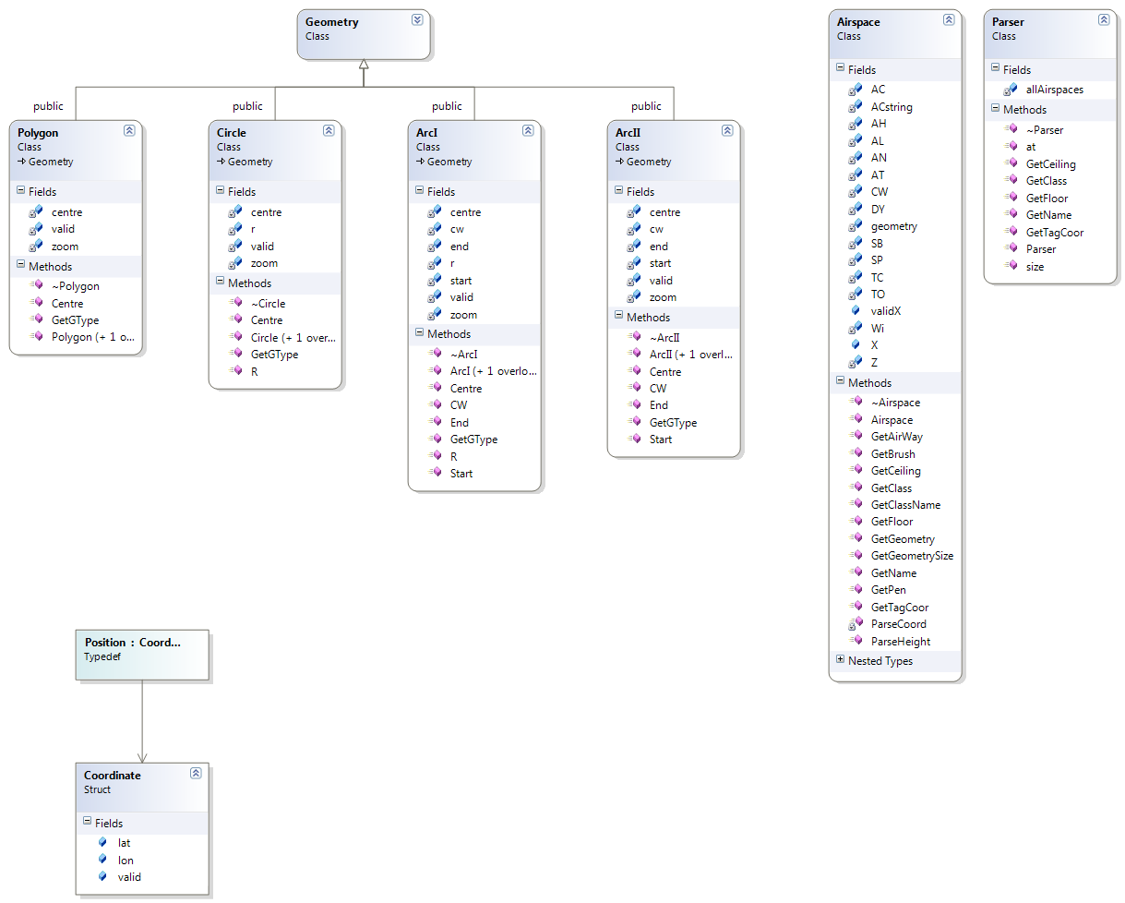

Figure 8 : This graphic shows the classes of the OpenAir(tm) airspace file parser. Each cell shows the variables and method of the particular class.

Output of the parser is the member of *OpenAirspace::Parser* class containing information about all the airspaces described in particular file. The only private variable of this class is the *allAirspaces* array of *OpenAirspace::Airspace* members. Each such a member contains parsed information about one airspace. This concludes the pen and brush colour, name, class, ceiling, floor, geometric primitives forming the airspace boundaries and more.

The OpenAir(tm) *Parser* library is linked to the main project as a dynamic library.

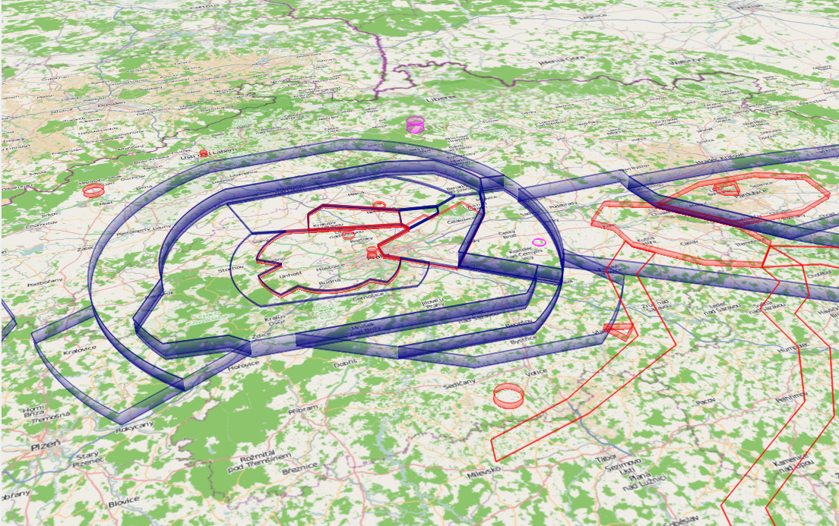

Figure 9. Example of the OpenAir(tm) data visualisations.

### OpenAir(tm) drawing engine

The main class connected to the *Core* is the *Airspaces* class. This class is responsible for the communication with the core and for calling the airspace drawing engine and parser. In the initial phase of the plug-in load the *Airspaces* all the files in */data/airspaces* folder are processed. During the program run also the user-imported files are drawn and the file is stored in */data/airspaces* directory. Each of the files, which needs to be processed is given to the drawing engine, specifically the *oaEngine* class constructor. This method is then responsible for calling the parser.

As mentioned above the output of the parser is the member of *OpenAirspace::Parser* class containing information about all the airspaces described in particular file. This member contains in fact an array of parsed airspaces for the given region and is the main outcome of the parsing process. Each of the airspaces in array is then processed in such a way, that first the colour specification is read (this is often common for whole the file or at least for group of airspaces) or the default colour is assigned. Next the geometry is created for each of the airspace’s set of points and arcs forming a closed polygon or a circle. The final geometry which is to be drawn consists of bottom polygon and the top polygon. Both the polygons being topologically identical each of them is located at height assigned as a floor and ceiling of the airspace respectively. Data defining the polygons were parsed during the process described above. The array of point pairs (bottom polygon point and corresponding top polygon point) defines the triangle strip OpenGL primitive used to visualize the side of the airspace. As mentioned earlier the OpenAir(tm) format defines the airspace as a circle primitive or as a closed polygon consisting of a set of points and arcs. OpenGL is based on processing the triangle meshes defined as a set of vertices for performance reasons. Thus all the arcs, as well as circles declared must be converted to a set of points allowing the use of OpenGL mesh setup. Granularity of this conversion is defined as a constant within *oaEngine* class. Because all the data defining the airspace are in WGS84 format, many arbitrary algorithms which work with this coordinate system had to be introduced. The main aim of these procedures is to compute the set of points from given airspace geometry. These points can be then used for filling the vertex array of the OpenGL utilising the methods of OSG Earth. These are used to correctly transform the WGS84 coordinates of vertices to the OpenGL world view and for correct evaluation of the terrain height from the height field data provided by OSG Earth.

Such a filled OpenGL vertex array is added to a scene graph node as a set geometry. Each node is now defining single particular airspace. Finally the set of OpenGL switches is used to ensure correct evaluation of transparency effects and visibility of the airspaces. The nodes are accumulated in map nodes array, which is handed back to the *Airspaces* class.

Each of the node in the array is added by *Airspaces* class to the scene tree of OSG as a map layer. In the same time the GUI display tree is created and signals for displaying the defined layers connected.

The Parser library is contained in following files located in /Updraft/src/plugins/airspaces/ folder.

* 1. *airspaces.cpp* - the main interface of the plug-in
  2. *airspaces.h -* the airspaces plug-in interface
  3. *oaengine.cpp* - the main airspace drawing engine
  4. *oaengine.h -* the OpenAir(tm) drawing engine class and methods declarations

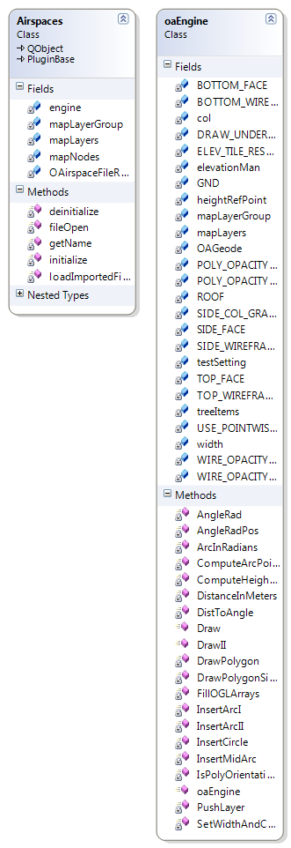

Figure : Airspaces plug-in classes. In each of the cells the variables and methods of the particular class are stated.

The *Airspaces* plug-in library is linked to the main project as a dynamic library.

### 3rd party software used

* Nokia Qt [4] for the GUI framework
* OSG [9] – as a OpenGL framework, for the mesh visualisation
* OSG Earth [10] – for the world-view matrix transformations

### The Airspaces plug-in diagram

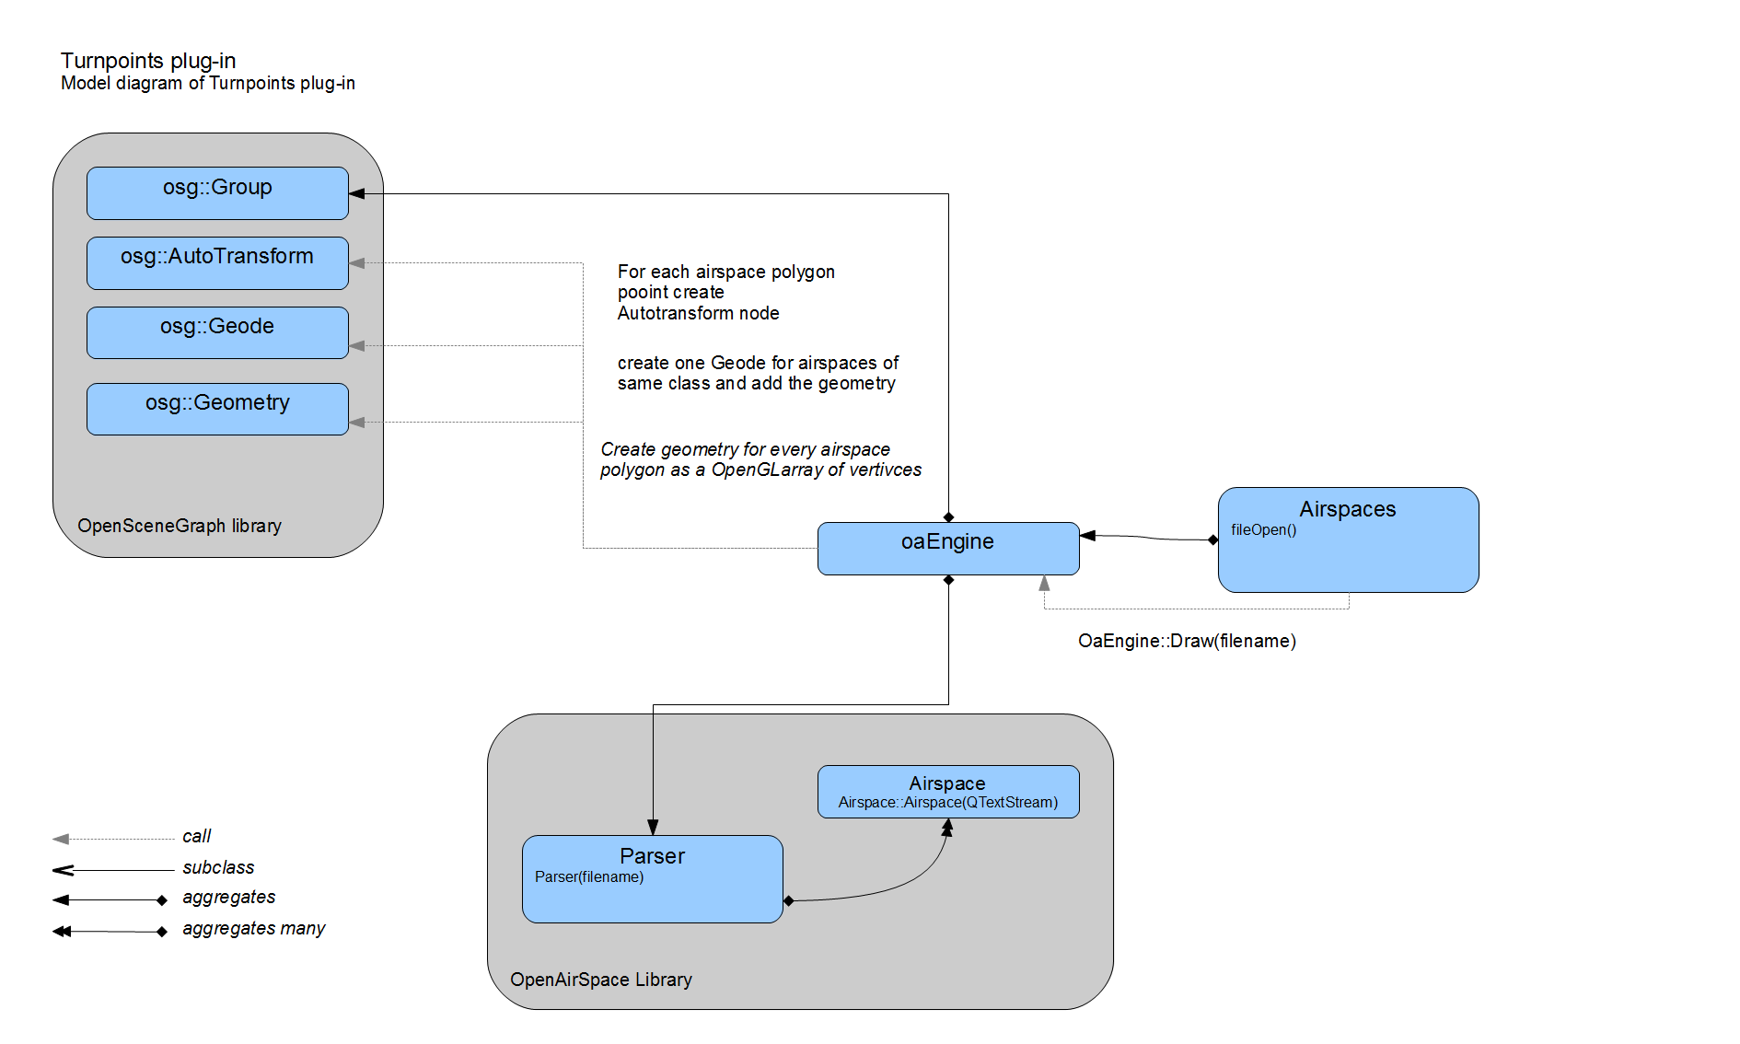

Figure : Airspaces plug-in and OpenAir parser diagram.

## TurnPoints

### Introduction

During the glider competition flight the typical task of a pilot is to navigate through the given set of waypoints usually forming a triangle. Each point is defined by its geographical coordinates, typically in WGS84 coordinate system. We will call such a point the *turn-point.* It is common practice (especially during competition) that there is a predefined set of such points. The set is distributed electronically as a file containing all the turn-points (e.g. by competition organizers) concerning the particular area. These turn-points therefore play an important role in flight planning procedure. Hence it is very useful for our software to have the turn-points visualisation capability. It is also very convenient way to visualise the airports whenever is this information provided by the turn-points file.

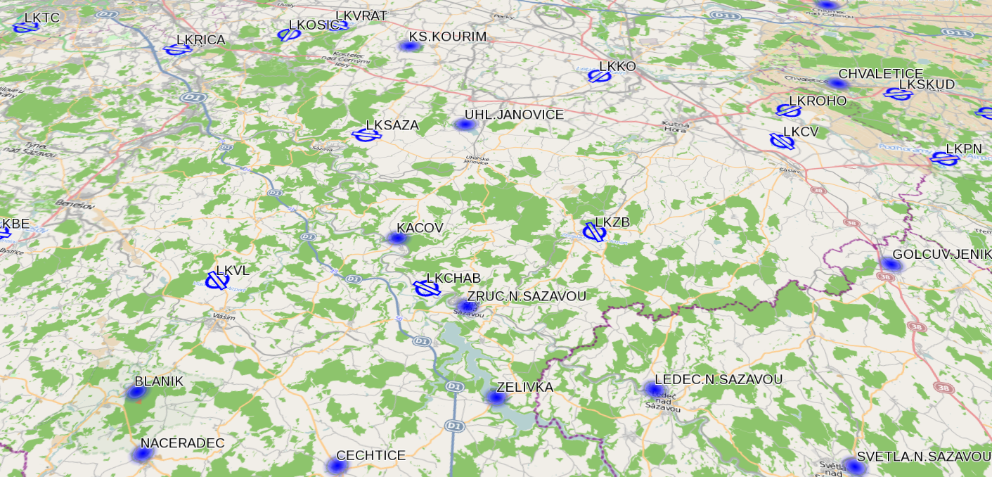

Figure 12. Turnpoints visualisation example.

### Overview

This plug-in is intended to collect and visualize turn-points. It uses Updraft Cup library, which implements parsing and loading turn-points from SeeYou *cup* files. For the cup file format description please see the Appendix D – Cup File Format Description. Loading turn-points from any file format is potentially possible – the plug-in is easily extendable and it doesn't depend on cup file format. It is a good practise that the definition of the turn-point also contains the information about the turn-point type, one of which is the Airport type. Together with this the detailed information about the airport, such as main runway heading or airport type, is often provided. In our application we utilise this information for distinguishing the airport from the common turn-point using different icons. In case of airport visualisation, we also use the information about the runway heading to correctly situate the icon.

### Design

The Turn-points plug-in is loaded by the core the same way any other plug-in is. The plug-in register the file type associated with the plug-in in the initial phase. It also loads all the cached files in the designated turn-points directory. Please see chapter _________________(file registration) for more detailed description. For each of the files the cup file parser library is called to extract the information about the turn-points from the files. Subsequently the algorithm for visualising the parsed data is called. It processes each of the turn-points and using the information about the type, geographical position and height it creates the icons, which forms the independent map layer. This map layer is then added to the OSG scene with the means described in ____________________(mapLayer).

### TPLayer Class

This class is responsible for creating the geometry from the parsed data utilising the OSG methods for creating the OSG nodes and further using the OSG transformation matrices for positioning the data into the scene. It also encapsulates the geometry to the map layer, which is finally added to the OSG scene to be visible in the map window.

### TPFileCupAdapter Class

This class is a part of the Turnpoints plug-in and serves as an intermediate layer between the CupFile class and the Turnpoints plug-in. It prepares the parsed data in such a way, that these can be used by the TPLayer class for visualisation. This class is responsible for loading the cup files by calling the cup parser.

### Cup File Parser

Each of the file containing the turn-points needs to be read, data it contains extracted and encapsulated in class data structure to be accessible by the turn-points plug-in. In case of the SeeYou Cup format (see the detailed description in the Appendix D – Cup File Format Description) these data are held in *Updraft::CupFile* class. Data in this format are prepared for use by the Turnpoints plug-in.

### Turnponts Plug-in Diagram

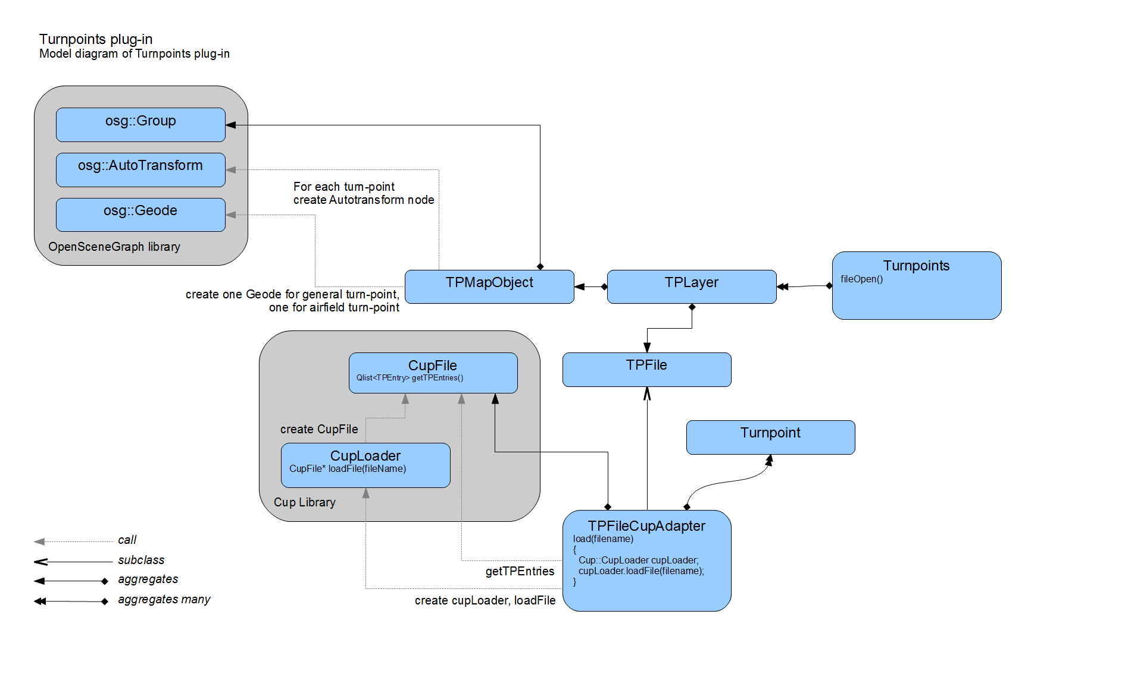

Figure 13. Turn-points plug-in design.

## Task Declaration

## IGC Visualisation

### Introduction

For the purposes of flight debriefing or contest scoring, the flight information is recorded using specialised flight loggers. Loggers export data in a standardized IGC file format[6].

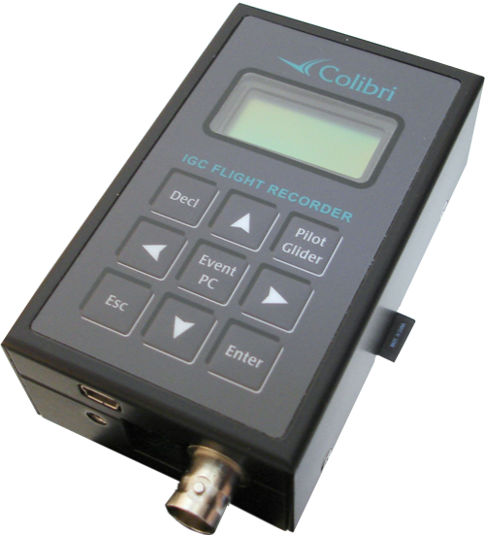

Figure 14. Colibri flight logger. Picture taken from internet[7].

Role of this plug-in is to visualize recorded flight tracks opened from an IGC file, and provide interactive statistics of the flight. These statistics include the colour-coded information about elevation, airspeed, vertical speed, and others.

### Model

The plug-in functionality is divided into two parts:

* the IGC file parser that gets the raw data from the IGC log
* the visualisation plug-in that visualises the IGC track, and computes the statistics from the data

### Igc Parser

Igc parser plug-in project is located in the directory /Updraft/src/libraries/igc, with several automated tests in the directory /tests. The parser itself is a simple top-down parser, reading lines, each one as a record.

Input file is represented by *QIODevice*, but a convenient method that requires only file name as a string is available as well.

All text fields of the IGC file are decoded using selectable codec (Latin 1 by default).

Data items that are allowed only once per IGC file, such as pilot name, glider identification, flight date, etc..., are stored as simple class variables with appropriate getter methods. If a field is absent from the file, then the getter method returns default constructed value.

Values that occur multiple times during the flight (Currently only GPS fix and pilot event) are stored as subclasses of *Event* in a chronological list together with their timestamp. When used, events usually need to be up-casted based on their *type* field.

### IGC Viewer plug-in

Class *IgcViewer* in /Updraft/src/plugins/igcviewer directory is an Updraft plug-in for IGC file visualisation and statistics computation that works with the data provided by Igc parser.

It registers the file type `*.igc`, holds the list of currently opened IGC files, and keeps automatic colourings for IGC files so that different IGC tracks have different colours, to be easily separable.

Each opened file is represented by an *OpenedFile* instance, which is stored in a container indexed by the file name. This container is checked every time a new file is opened to avoid duplicate opening. Opened file creates geometry, and handles the statistics window in the bottom tab bar of the updraft window.

The workflow of opening a file is the following:

1. *IgcViewer* gets an event that a file has been opened, and gets the filename of the file.
2. It creates the *OpenedFile* instance, computes its default colour, and lets it initialize, passing the filename.
3. *OpenedFile* calls the Igc parser on the file, and from the GPS events list creates a *Fix List*.
4. The track geometry is created.
5. *OpenedFile* creates the *FixInfo* instances from the *Fix List* - classes that hold various statistics info per each fix.
6. The tab with the statistics is created.

#### Fix List

Fix list is a list of events from the IGC parser, filtered to contain only GPS fixes and wrapped into a new structure, together with the GPS location coordinates projected to geometry world coordinates (X, Y, Z). Once the fix list is created, the original events from the parser are not used any more.

#### Visualisation

##### Track Geometry

Track of the IGC file visible in the map is created in the method *OpenedFile::createGroup*, which creates the geometry as an OpenSceneGraph *osg::Group* scene node.

This group consists of:

* the actual 3D track - a line strip
* track markers - small circles that mark the locations the statistics are computed on
* the transparent "skirt" to enhance 3D effect and to mark the ground projection of the flight track.

Most of the Geometry is fixed, however position of the marker changes with every click on the map or on the graph (see below) and colours of the track change with user setting.

##### Track Colouring

Track colouring is selectable from a combo box in the tab GUI.

Tracks can be coloured using:

* automatic colouring
* vertical speed
* ground speed
* altitude
* time

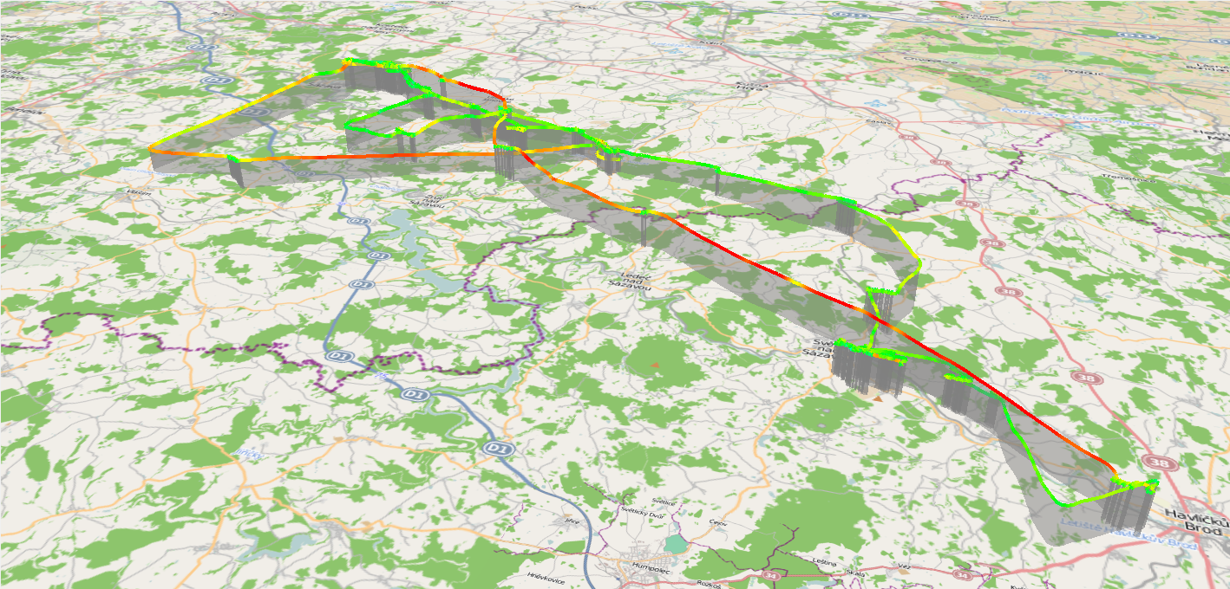

Figure 15. IGC track Ground speed colouring example.

Colourings are represented by the class *Colorin*g. It provides colour for given index of the track fix. Subclasses of *Coloring* mostly (with the exception of automatic colour) receive pointer to *FixInfo* and a gradient.

Automatic colouring rotates colours of each opened file from a predefined list. Each colour in the list has a use count and every time a new IGC file is opened, one colour with the least uses is selected. Selection of automatic colour is done in the class *IgcViewer* and the selected colour is passed to the opened file class during initialization.

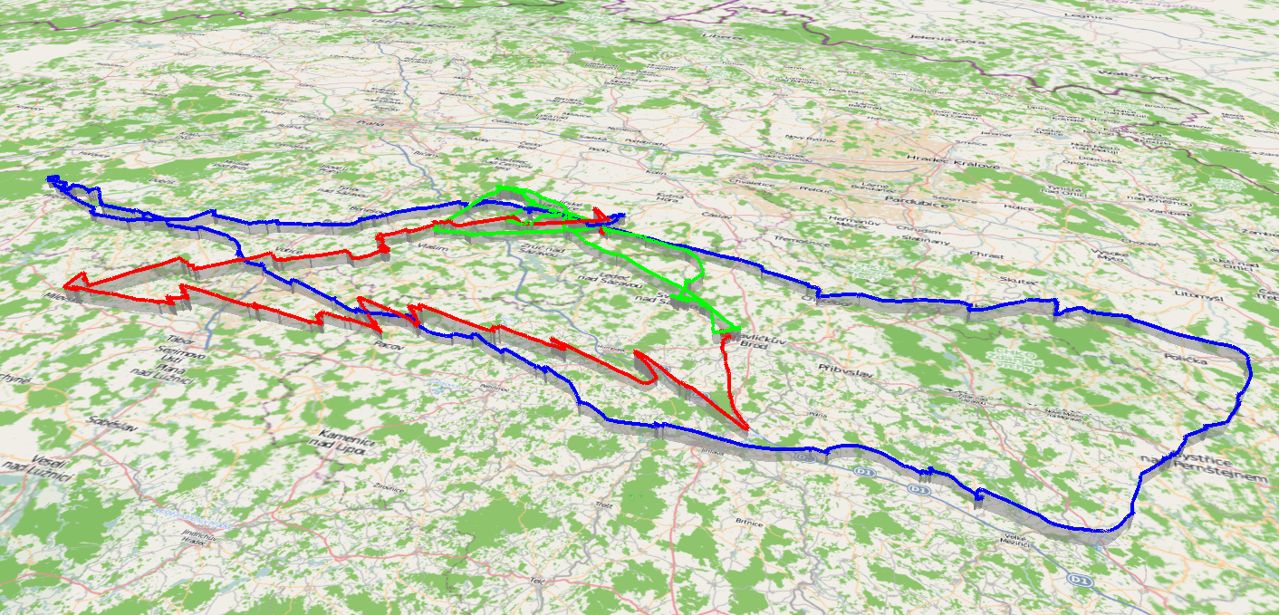

Figure 16. IGC tracks automatic colouring.

#### Statistics computation

Statistics are visualized in the bottom tab window, allowing user interaction. The basic class for the statistics is the *FixInfo*.

##### Class FixInfo

Class *FixInfo* is an abstract class that represents values that can be extracted from every fix of the IGC track. Subclasses of this class exist for altitude, vertical speed and ground speed.

*FixInfo* classes are defined in files /Updraft/src/plugins/igcviewer/igcinfo.cpp and /Updraft/src/plugins/igcviewer/igcinfo.cpp.

Other than retrieving the value at given point, *FixInfo*`s provide four types of scaling information, which is used in graph plotting. `*min*` & `*max*` are simple minimum and maximum value. Robust versions skip top and bottom 3 % of the values, and global versions cover all opened IGC files.

For example $globalRobustMin=\min_{x∈openedFiles}{robustMin_{x}}$.

The global colourings are updated every time an IGC file is opened or closed using method *OpenedFile::updateScales* to provide a visual overview of the track values that are scaled to match all the opened files.

##### Class SegmentInfo

Class *SegmentInfo* provides statistics for track segments. It holds the *FixList* instance, and provides statistics between 2 fixes.

##### Statistics visualisation

Statistics are plotted in a graph in the *PlotWidget* window, which also provides user interaction statistics.

##### PlotWidget class

*PlotWidget* contains plots of the *FixInfo* values for various statistics, and provides user interaction for picking out points, and segments to compute the statistics from. For better performance, the plots and statistics are not drawn into the widget every *paintEvent*. They are drawn into a *QImage*, and redrawn only at resize events, or when the statistics texts are changed.

##### Graph plots

###### Axes

Basic concept of graph plots are the axes. Axes determine position, size and scaling of the plotted data and draw tick marks. Axes are derived from *QLayoutItem*, this enables us to use Qt's native layouts in the plot widget.

###### Plot Painters

Plot painters are classes that are given the axes and the *FixInfo*, and plot the data into the graph. There are several subclasses of the abstract *PlotPainter* class, each plotting a different statistic in a different style.

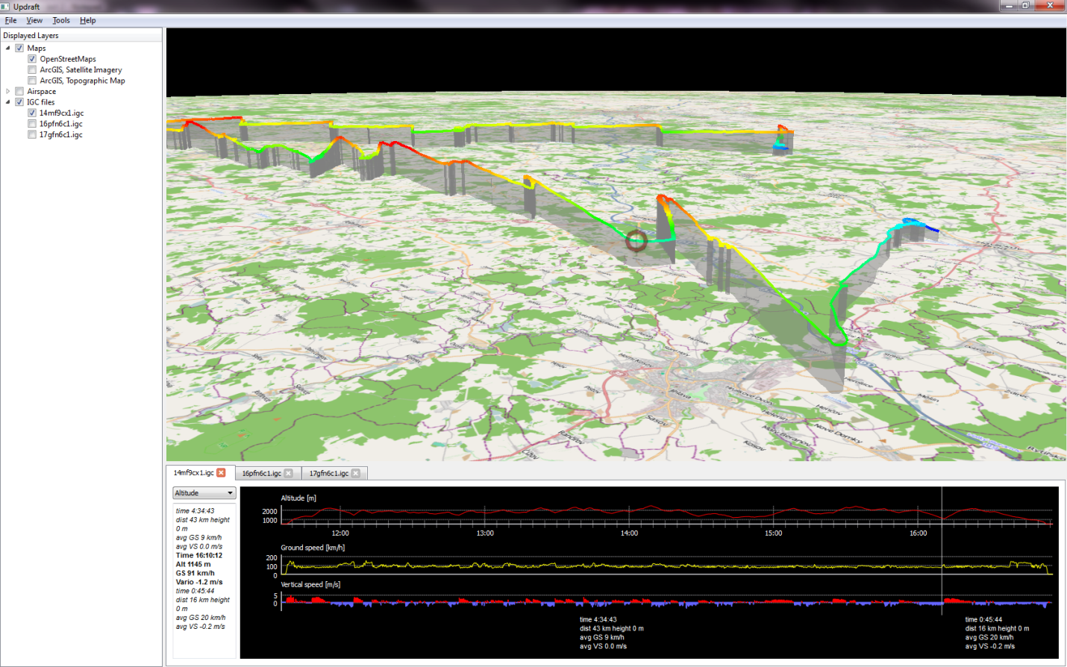

Figure 17. IGC visualisation with altitude colour code. The black pane shows the flight graphs. Mouse picked point for the fix statistics shown as a red circle on the map and a vertical line on the graph plot.

##### Statistics upon mouse interaction

###### Fix statistics

Upon mouse move, or mouse click, the given track fix is computed from the mouse location, and the information of this track-fix are gotten from the *FixInfo* sub-classes. The statistics are stored in text form, and after creating the text string, the string is then passed to *IgcTextWidget* to display. A signal is emitted to set the position of the track marker on the 3D track, on the location of the fix the user has clicked, or is currently pointing.

A fix can also be picked out when clicking on the 3D track. Then, the *OpenedFile* emits a signal with the fix index the user has clicked on, and *PlotWidget* catches this signal and adds a new picked fix. The statistics for this fix and the segments are then computed.

###### Segment statistics

When user picks out a fix (either by clicking on the graph, or clicking on the 3D track), the segment statistics between the points are computed. The segment statistics are saved in a text form, and passed to *IgcTextWidget*, and to *PickedLabel* classes for the display.

### Plug-in Design Scheme

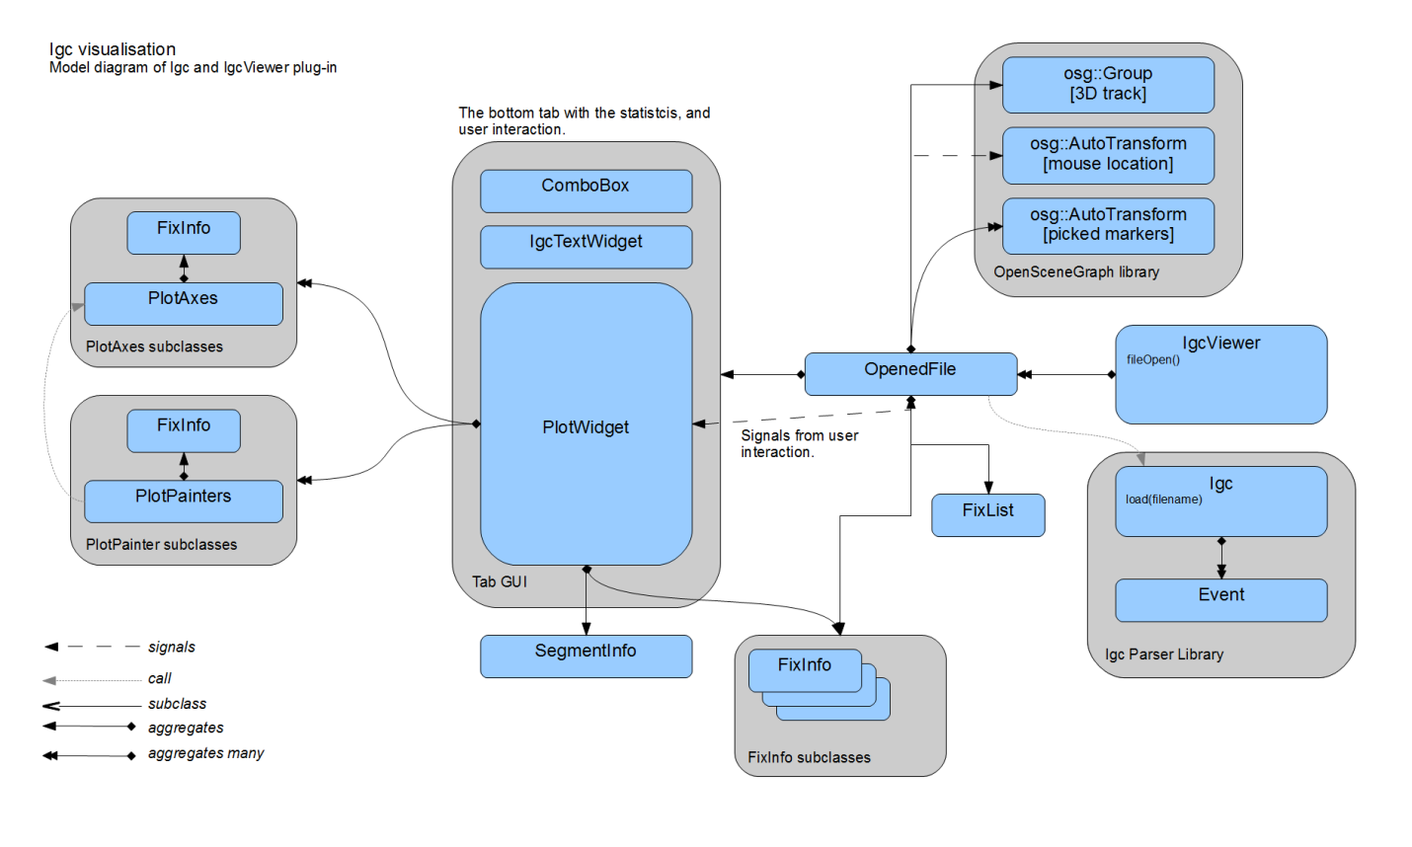

Figure 18. IGC Visualisation plug-in scheme.

# Program installation

## Windows

## Linux

## Mac

# Conclusion

We have created this application to serve the glider pilots as a glider path planning and flight visualisation tool. It is a free easy-to use alternative, and we believe even an improvement, to the commercial product *SeeYou*. The main targets we set ourselves as a goal has been all reached. The application has proven to be smoothly running on all of the designated platforms, i.e. Windows, Linux and Mac OS. The implemented features include the *Airspaces* plug-in for airspace division visualisation, the *Turnpoints* plug-in for the waypoints visualisation, the *TaskDeclataion* plug-in for the flight planning and the *IGC visualisation* plug-in for the recorded flight path visualisation. All these features are incorporated to the nice looking 3D map environment including several map types and even the terrain elevation visualisation.

# Future work

The application is designed to be expandable. We anticipate the development of the product to continue in the future. The Qt core/plug-in system we have chosen is ideal for addition of new plug-ins such as the weather plug-in, or the interface for flight data download directly from the logger device. Additionally all the plug-ins working with files are easily extendable to accommodate parsers and data processors for future file formats, e.g. *Airspaces*, *Turnpoints* or *IGC visualisation* plug-ins.

# References

|  |  |
| --- | --- |
| [1] | Naviter, "SeeYou," Naviter, [Online]. Available: http://naviter.si/index.php?option=com_content&task=view&id=9&Itemid=213. |
| [2] | "FreeLists," [Online]. Available: http://www.freelists.org. |
| [3] | Google, "Google C++ Style Guide," [Online]. Available: http://google-styleguide.googlecode.com/svn/trunk/cppguide.xml. |
| [4] | Nokia, "Qt," Nokia, [Online]. Available: http://qt.nokia.com/. |
| [5] | Microsoft, "Visual Studio 2008," Microsoft, [Online]. Available: http://www.microsoft.com/visualstudio/en-us/products/2008-editions. |
| [6] | Open-source, "CMake," [Online]. Available: http://www.cmake.org/. |
| [7] | L. Torvalds. [Online]. Available: http://git-scm.com/. |
| [8] | "GitHub," [Online]. Available: http://www.github.com. |
| [9] | Open-source, "The OpenSceneGraph," [Online]. Available: http://www.openscenegraph.org. |
| [10] | G. W. Jason Beverage, "OSG Earth," Pelican Mapping, [Online]. Available: http://osgearth.org. |
| [11] | C. Karney, "GeographicLib," [Online]. Available: http://geographiclib.sourceforge.net/. |
| [12] | Wikipedia, "Qt framework," [Online]. Available: http://en.wikipedia.org/wiki/Qt_(framework). |
| [13] | K. Gtoup, "OpenGL," [Online]. Available: http://www.opengl.org/. |
| [14] | Open-source, "OpenStreetMap," [Online]. Available: http://tile.openstreetmap.org/. |
| [15] | ESRI, "Imagery World 2D," [Online]. Available: http://server.arcgisonline.com/ArcGIS/rest/services/ESRI_Imagery_World_2D/MapServer. |
| [16] | ESRI, "World Topo Map," ESRI, [Online]. Available: http://server.arcgisonline.com/ArcGIS/rest/services/World_Topo_Map/MapServer. |
| [17] | G. W. Jason Beverage, "Ready map elevation tiles," Pelican Mapping, [Online]. Available: http://readymap.org/readymap/tiles/1.0.0/9/. |
| [18] | Wikipedia, "World Geodetic System," [Online]. Available: http://en.wikipedia.org/wiki/World_Geodetic_System. |

# Tables

Table 1 : Team members main responsibilities. 5

# Figures

Figure 1. The OSGEarth framework example. 9

Figure 2. OpenStreetMap source. 11

Figure 3. ArcGIS online map service. 11

Figure 4. Application architecture diagram. 12

Figure 5. Top level structure diagram. 14

Figure 6. Western European Airspaces. 19

Figure 7. Example of airspace divisions visualisation. 20

Figure 8 : This graphic shows the classes of the OpenAir(tm) airspace file parser. Each cell shows the variables and method of the particular class. 22

Figure 9. Example of the OpenAir(tm) data visualisations. 23

Figure 10 : Airspaces plug-in classes. In each of the cells the variables and methods of the particular class are stated. 25

Figure 11 : Airspaces plug-in and OpenAir parser diagram. 26

Figure 12. Turnpoints visualisation example. 27

Figure 13. Turn-points plug-in design. 29

Figure 14. Colibri flight logger. Picture taken from internet. 31

Figure 15. IGC track Ground speed colouring example. 34

Figure 16. IGC tracks automatic colouring. 35

Figure 17. IGC visualisation with altitude colour code. The black pane shows the flight graphs. Mouse picked point for the fix statistics shown as a red circle on the map and a vertical line on the graph plot. 36

Figure 18. IGC Visualisation plug-in scheme. 37

# Appendix A – People

***Alexander Wilkie*** – Computer Graphics Senior Lecturer on Faculty of Mathematics and Physics by Charles University, Prague, Czech Republic;

***Tomáš Zámečník*** – Student of Computer Science master degree on Faculty of Mathematics and Physics by Charles University, Prague, Czech Republic;

***Čestmír******Houška***– Student of Computer Science master degree on Faculty of Mathematics and Physics by Charles University, Prague, Czech Republic;

***Jakub******Marek*** – Student of Computer Science master degree on Faculty of Mathematics and Physics by Charles University, Prague, Czech Republic;

***Bohdan******Maslowski*** – Student of Computer Science master degree on Faculty of Mathematics and Physics by Charles University, Prague, Czech Republic;

***Mária Vámošová*** - Student of Computer Science master degree on Faculty of Mathematics and Physics by Charles University, Prague, Czech Republic;

***Aleš******Zita*** – Student of Computer Science master degree on Faculty of Mathematics and Physics by Charles University, Prague, Czech Republic;

# Appendix B – OpenAir(tm) airspace format definition

Following is the definition of the OpenAir(tm) format as provided on the winpilot[8] web page.

**OPEN AIR** (tm) TERRAIN and AIRSPACE DESCRIPTION LANGUAGE   
 Version 1.0  
 December 10, 1998  
 Updated October 15, 1999  
 Send comments to jerryp@winpilot.com  
  
  
 AIRSPACE related record types:  
 ==============================  
  
 **AC class** ; class = Airspace Class, see below:  
 **R** restricted  
 **Q** danger  
 **P** prohibited  
 **A** Class A  
 **B** Class B  
 **C** Class C  
 **D** Class D   
 **GP** glider prohibited   
 **CTR** CTR  
 **W** Wave Window  
  
  
 **AN string** ; string = Airspace Name  
 **AH string** ; string = Airspace Ceiling  
 **AL string** ; string = Airspace Floor  
 **AT coordinate** ; coordinate = Coordinate of where to place a name label on the map (optional)  
 ; NOTE: there can be multiple AT records for a single airspace segment  
   
   
 TERRAIN related record types (WinPilot version 1.130 and newer):  
 ==============================  
  
 **TO** {string} ; Declares Terrain Open Polygon; string = name (optional)  
 **TC** {string} ; Declares Terrain Closed Polygon; string = name (optional)  
 **SP style, width, red, green, blue** ; Selects Pen to be used in drawing  
 **SB red, green, blue** ; Selects Brush to be used in drawing  
  
   
 Record types common to both TERRAIN and AIRSPACE  
 =================================================  
  
 **V x=n** ; Variable assignment.  
 ; Currently the following variables are supported:  
 ; D={+|-} sets direction for: DA and DB records  
 ; '-' means counterclockwise direction; '+' is the default  
 ; automatically reset to '+' at the begining of new airspace segment   
 ; X=coordinate : sets the center for the following records: DA, DB, and DC   
 ; W=number : sets the width of an airway in nm (NYI)  
 ; Z=number : sets zoom level at which the element becomes visible (WP version 1.130 and newer)  
  
 **DP coordinate** ; add polygon pointC  
 **DA radius, angleStart, angleEnd** ; add an arc, angles in degrees, radius in nm (set center using V X=...)  
 **DB coordinate1, coordinate2** ; add an arc, from coordinate1 to coordinate2 (set center using V X=...)  
 **DC radius** ; draw a circle (center taken from the previous V X=... record, radius in nm  
 **DY coordinate** ; add a segment of an airway (NYI)

# Appendix C – Cup File Format Description

Each line represents one waypoint with these fields, separated by commas. Here is an example:

"Lesce-Bled","LESCE",SI,4621.666N,01410.332E,505.0m,2,130,1140.0m,

"123.50","Home airfield"

**1. Name**

This is the long name for the waypoint. It is supposed to be ebraced in double quotes to allow any

characters, including a comma in between. This field must not be empty.

**2. Code**

Also known as short name for a waypoint. Many GPS devicees cannot store long waypoint names, so

this field will store a short name to be used in various GPS types. It is advisable to put it in double

quotes.

**3. Country**

IANA Top level domain standard is used for the country codes. A complete list is available at

<http://www.iana.org/cctld/cctld-whois.htm>

**4. Latitude**

It is a decimal number where

1-2 characters are degrees,

3-4 characters are minutes,

5 decimal point,

6-8 characters are decimal minutes.

The ellipsoid used is WGS-1984

**5. Longitude**

It is a decimal number where

1-3 characters are degrees,

4-5 characters are minutes,

6 decimal point,

7-9 characters are decimal minutes.

The ellipsoid used is WGS-1984

**6. Elevation**

It is a string with a number with unit attached. Unit can be either

"m" for meters or

"ft" for feet.

Decimal separator must be a point.

**7. Waypoint style**

It is a digit representing these values:

1 - Normal

2 - AirfieldGrass

3 - Outlanding

4 – GliderSite

5 - AirfieldSolid

6 - MtPass

7 - MtTop

8 - Sender

9 - Vor

10 - Ndb

11 - CoolTower

12 - Dam

13 - Tunnel

14 - Bridge

15 - PowerPlant

16 - Castle

17 - Intersection

**8. Runway direction**

It is a string in degrees representing heading of the runway. Only used with Waypoint style types 2, 3,

4 and 5

**9. Runway length**

It is a string for number with unit representing length of the runway. Only used with Waypoint style

types 2, 3, 4 and 5

unit can be either

"m" for meters

"nm" for nautical miles

"ml" for statute miles

Decimal separator must be a point.

**10. Airport Frequency**

It is a string representing the frequency of the airport. Decimal separator must be a point. It can also

be embraced in double quotes.

**11. Description**

It is a string field with no limitation in length where anything can be stored in. It should be embraced

with double quotes.

# Appendix D – Elevation dataset usage confirmation

Od: "Glenn Waldron" <gwaldron@pelicanmapping.com>

Komu: "Ales Zita" <ales.zita@volny.cz>

Předmět: Re: ReadyMap elevation data

Datum: 10.12.2011 - 15:53:03

Ales,

You are welcome to use the server for your project and for a

freeware app.

Thanks for asking, and if you have any issues or questions, don't

hesitate

to email me.

Glenn Waldron / Pelican Mapping / @glennwaldron

On Sat, Dec 10, 2011 at 5:57 AM, Ales Zita <ales.zita@volny.cz>

wrote:

> From: Ales Zita <ales.zita@volny.cz>

> Subject: ReadyMap elevation data

>

> Message Body:

> Hello,

>

> I'd like to ask for permission to use the world-wide elevation

> data for

> > our school project.

>

> We are a group of 6 people developing the the glider flightpath

> visualisation tool in osgEarth environment as a school project at

> Faculty

> > of Mathematics and Physics by the Charles University in Prague.

> As this is non commertial project, we cannot afford any paid

> elevation

> > data sources. Therefore we would very much appreciate the use of

> your

> > ReadyMap global elevation dataset accessible via the osgEarth api.

>

> Should this project become available as a freeware at some point,

> can we

> > continue to use your server as a souce of the elevation data?

>

> Thank you

>

> Kind regards

>

> Ales Zita

>

> --

> This mail is sent via contact form on Pelican Mapping

> http://pelicanmapping.com

# Appendix E – DVD content

1. http://updraft.github.com/
2. http://osgearth.org/wiki/TileSourcePlugins
3. http://resources.esri.com/arcgisonlineservices/index.cfm?fa=content
4. http://resources.esri.com/arcgisonlineservices/index.cfm?fa=content
5. http://www.winpilot.com/UsersGuide/UserAirspace.asp
6. http://web.archive.org/web/20100723171307/http://www.fai.org/gliding/system/files/tech_spec_gnss.pdf
7. http://www.lxnavigation.si/avionics/images/avionics/Slike/Colibri_mala.png
8. http://www.winpilot.com/UsersGuide/UserAirspace.asp